Forging ON:
The Evolution of Blacksmithing in Ontario

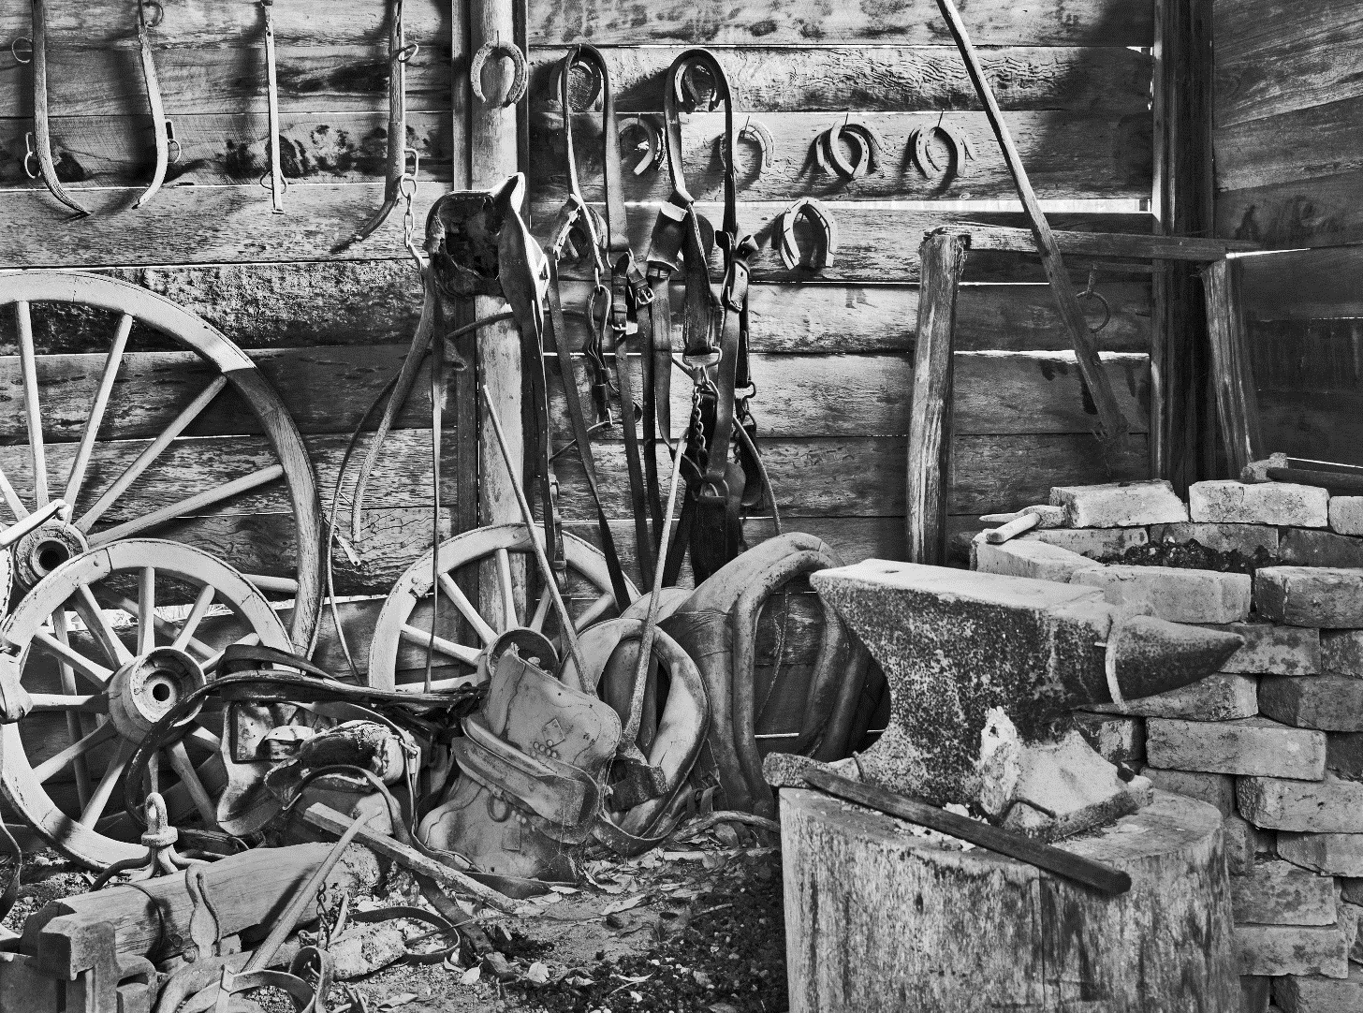

150 Years of Blacksmithing in Canada

Forging ON: The Evolution of Blacksmithing in Ontario
150 Years of Blacksmithing in Canada

Subject: History
Topic: 150 Years of Blacksmithing in Canada
Grade Level: 7 to 12
Time Required: 3-4 classes, or 2 classes and homework for 2 nights

Overview
Students will explore, interpret, and analyze primary and secondary sources relating to blacksmithing in Canada between 1810 and 1960 with the help of a Scavenger Hunt worksheet and the “Forging ON: The Evolution of Blacksmithing in Ontario” website. They will then use this research as the basis for a roleplaying exercise which will be presented to the class.

Objectives/Expectations
This exercise will emphasize two historical thinking concepts: Continuity and Change and Historical Perspective. It will also help familiarize students with the Historical Inquiry Process. Students will learn how to gather and organize primary and secondary sources which are relevant to their research, how these sources should be interpreted and analyzed, what conclusions can be drawn from this research and how it can be synthesized into a cohesive narrative or argument, and finally how this can be communicated using various formats for specific audiences.

Curriculum Links
Grade 7:
- Grade 7, History, Strand B. Canada, 1800 – 1850 Conflict and Challenges, Section B1. Analyse aspects of the lives of various groups and communities in Canada between 1800 and 1850;
- Grade 7, History, Strand B. Canada, 1800-1850: Conflict and Challenges, Application: Changes and Challenges, Section B1.2. Analyse some of the challenges facing individuals, groups and communities in Canada between 1800 and 1850 and ways in which people responded to those challenges
- Grade 7, History, Strand A. New France and British North America, 1713 - 1800, Understanding Historical Context: Events and Their Consequences, Section A3.4. Identify key social and economic changes that occurred in and/or affected Canada during this period and explain the impact of some of those changes on various individuals, groups, and/or communities;

Grade 8:
- Grade 8, History, Strand A. Creating Canada, 1850 – 1890, Section A1. Assess the impact of some key social, economic, and political factors, including social, economic, and/or political inequalities, on various groups and communities;
- Grade 8, History, Strand B. Canada, 1890-1914: A Changing Society, Applications: Canada – Past and Present, Section B1.3. Analyse some of the challenges facing various individuals, groups, and/or communities in Canada between 1850 and 1914

Grade 10:
- Grade 10 Academic, Canadian History since World War I, Strand B. Canada, 1914-1929, Social, Economic, and Political Context, Section B1.1. Identify major demographic trends in Canada;
- Grade 10 Academic, Canadian History since World War I, Strand B. Canada, 1914-1929. Social, Economic, and Political Context, Section B1.2. Identify some major developments in science and technology and assess their significance for different groups in Canada;
- Grade 10 Academic, Canadian History since World War I, Strand B. Canada, 1914-1929, Social, Economic, and Political Context, Section B1.3. Describe some key economic trends and developments and assess their impact on various groups

Grade 12:
- Grade 12 College Preparation, World History since the Fifteenth Century, Strand D. World History since the Fifteenth Century, Grade 12, The World, 1789 – 1900. Section D1. Explain the impact of some key social, economic, and political developments in different regions between 1789 and 1900, with a particular emphasis on the Industrial Revolution;
- Grade 12 University Preparation, Canadian and World Studies, Strand C. Canada, 1774 – 1867, Setting the Context, Section C1.2. Describe some major technological and/or scientific developments during this period and assess their impact on people living in Canada;
- Grade 12 University Preparation, Canadian and World Studies, Strand C. Canada, 1774 – 1867, Setting the Context, Section C1.4. Describe various key economic trends and developments, including international trends/ developments, that affected Canada during this period;
- Grade 12 University Preparation, Canadian and World Studies, Strand C. Canada, 1774-1867, Interactions and Interdependence, Section C2.1. Analyse some of the challenges facing various communities in Canada during this period and how different communities responded to them

Materials & Sources
- “Forging ON: The Evolution of Blacksmithing in Ontario” website (www.ForgingON.ca)
- Primary and Secondary Sources Worksheet (Found on the “Forging ON” website)
- Answer Sheet for the Worksheets (found at the end of this document)
- Optional: Props, Costumes, Camera, Editing Software, Various Art Supplies

Procedure
- After a quick, preliminary explanation by the teacher, students are further introduced to the concept of primary and secondary historical sources through the completion of Part 1 of the worksheet.
- Students then explore the various features of the “Forging ON: The Evolution of Blacksmithing in Ontario” website using the scavenger hunt in Part 2 of the worksheet as a guide. Students should be allowed to consult with their classmates if facing any difficulties.
- Once completed, students are divided into three different time periods: 1800-1870, 1870-1890, 1890-1960.
- Students investigate the website’s timeline and the challenge videos in further depth as they relate to their assigned time period. They then answer the questions regarding secondary sources in Part 3 of the worksheet.
- Using the background historical context provided during the previous step, students search for information within the primary sources which will supplement their understanding of blacksmithing during their assigned era. They may then complete Part 3 of the worksheet.
- Students fill out Part 4 of the Sources Scavenger Hunt worksheet, which asks them to think critically about primary and secondary sources in general after analyzing specific examples in some depth.
- Students write a short paragraph summarizing what life was like for a blacksmith during their assigned era.
- Students then make or are assigned groups with students who are “experts” in different eras of blacksmithing. Using the research they have procured from both primary and secondary sources, students prepare and perform a “round-table interview” between the blacksmiths of various periods. This can be done in either the format of a live theatrical performance or a short film. Groups will brainstorm questions that the interviewer will ask, emphasizing historical perspective and continuity and change. The group will also provide a bibliography of the primary and secondary sources they relied on for their presentation.

Adaptations
Teachers can also allow students to work individually or in pairs to work on a piece of poetry, art, or short piece of historical fiction from the perspective of a blacksmith from their assigned era. They then explain which primary and secondary sources they utilized to inhabit the mindset of a blacksmith and to ensure historical accuracy. Subsequently, they compare their work with someone else’s of a different era and discuss the similarities and differences between the two as they relate to perspective, continuity, and change.

If the teacher wishes for the class to focus on one specific period only, as illustrated in the syllabus (i.e. Canada from 1800 to 1850), students can compare sources found within the era rather than between eras.

Notes
This lesson plan provides an entertaining, open-ended way for students to properly examine secondary and primary sources for relevant information and subsequently synthesize it into a creative work. This provides students with important academic experience and a real world application for historical research.

The lesson plan also pushes students to explore the website entirely and emphasizes its main narrative: How blacksmithing evolved, changed, and remained the same from the early 19th century to today and how it can be used as a demonstrative microcosm of Canada’s history over the past 150 years.

Forging ON: Primary and Secondary Sources Worksheet

Part 1: Scavenger Hunt

Use the “Blacksmithing Primary Sources” document for your scavenger hunt. Find the answer to at least ten of the following questions.

- Where can you find archival photographs that reveal how blacksmiths and their shops evolved in early 20th century Canada?

- Was blacksmithing an occupation that was passed down through a family’s generations? Where can you find a primary source that suggests this? (Hint: one example is a family’s series of ledgers)

- Were blacksmiths important in North American frontier towns? What sources, one primary and one secondary, can give us the answer?

- What sources give us insight on the experience of blacksmith apprentices?

- Where can you find primary sources not written by blacksmiths that indicate the importance of blacksmiths in rural areas of Ontario?

- How can one find out about the day to day activities of North American blacksmiths during the second half of the 19th century?

- What were the demographics of blacksmiths during the late 19th century? What sources illustrate this and/or demonstrate the experience of immigrant blacksmiths?

- What sources help reveal the characteristics, personalities, and values generally held by blacksmiths?

- Where can one find out the price of various pieces of blacksmithing equipment during the 1870s?

- How could one form an idea of the equipment Canadian blacksmiths relied upon during the early 20th century?

- How could one form an idea of the methods Canadian blacksmiths relied upon during the early 20th century?

- Where can one learn about the impact of industrialization, urbanization, and technological innovation during the mid to late 19th century on the blacksmithing trade?

- What were some important new pieces of blacksmithing equipment that emerged during the 1880s?

- What sources illustrate the effect the advent of automobiles and trains had on the blacksmithing trade?

- Did Canadian blacksmiths play a role during the First and Second World Wars? What primary sources can tell us the answer?

- Where can one view a recreation of a 19th century blacksmith forging a gate latch?

Part 2: Researching sources

- My assigned time period is:

- Find at least two examples of secondary sources as they relate to your assigned time period on the website and answer the following questions for each one:

  - What is the title of the source?

  - Who is the author (can be both a person or an organization)?

  - Who do you think is the author’s intended audience?

  - What does this source reveal about blacksmithing during your assigned era? What historical questions does this help you understand? Give at least three detailed examples of what you learned from it.

  - Does this source raise any further questions about the topic?

  - What are the limitations of this source?

- Find at least three examples of primary sources as they relate to your assigned period on the website and use them to answer the following questions:

  - What kind of primary source is it (diary, newspaper, letter, etc.)?

  - Who created it? What do you know about the author?

  - What is the origin of this source? When and where was it created?

  - For what purpose was this source created?

  - Who do you think the author’s intended audience was?

  - What does this source reveal about blacksmithing during your assigned era? What historical questions does this help you understand? Give at least three detailed examples of what you learned from it.

  - Does the source’s author show bias at any point? Describe any examples.

  - What perspective does this source present on the topic?

  - Does this source raise any further questions about the topic?

  - What were some difficulties or limitations you encountered when using this source?

  - Does this source relate to any of the other sources (primary and secondary) that you have looked at? Does it support and contradict them?

Part 3: Source Analysis

- Why is the historical context important when assessing primary sources?

- What are some of the general difficulties of using primary sources?

- Why is it important to study sources from different perspectives?

- What kind of information is provided by the primary source? Is it different from information provided by the secondary source? How?

- Why is it necessary for us to consider both primary and secondary resources when we look at history? Why should we use both types of sources in conjunction when doing historical research? What does each offer which the other cannot?

- What must we consider and watch out for when analyzing primary sources? How about when analyzing secondary sources?

- Make a chart comparing the advantages and disadvantages (benefits and limitations) of primary and secondary sources.

OPTIONAL: Look around your classroom or home. Identify possible artifacts and sources that future historians may look at 200 years from now. Answer the following questions:

- What will these sources reveal about life in the early 21st century? How might these sources affect future understanding of the period?

- What misconceptions might these sources produce?

- What aspects of our lives will be the most difficult for future historians to find out about?

Part 4: Research synthesis

- Based on your primary and secondary sources, write a short paragraph detailing what life was like for a blacksmith during your assigned era.

- You will make or be assigned in groups with “experts” in different eras of blacksmithing. Compare and contrast your short paragraphs. Then prepare and perform a “round-table interview” between the blacksmiths of various periods (through role-play). You will brainstorm questions that the interviewer will ask, emphasizing the varying perspectives of blacksmiths throughout the decades, how their lives, trade, and role in society changed or stayed the same, and what impact industrialization, urbanization, transportation and immigration had on them. This can be done in either the format of a live theatrical performance or a short film.

- Put together a bibliography of the various primary and secondary sources your group used to prepare for this presentation.

OPTIONAL: Given permission from your teacher, if you are not dramatically inclined, you can work on a piece of poetry, art, or short piece of historical fiction from the perspective of a blacksmith from your assigned era. You will then compare your work with someone else’s of a different era and discuss the similarities and differences between the two as they relate to perspective, continuity, and change.

Blacksmithing in Ontario: Primary and Secondary Sources Worksheet
ANSWER SHEET

Part 1: Scavenger Hunt

1. Where can you find archival photographs that reveal how blacksmiths and their shops evolved in early 20th century Canada?
ANSWER: A GUIDE TO RESEARCH IN THE HISTORY OF BLACKSMITHING

- Was blacksmithing an occupation that was passed down through a family’s generations? Where can you find a primary source that suggests this? (Hint: one example is a family’s series of ledgers)
ANSWER: Graybiel Blacksmith Ledger (however, there are more examples such as A Narrative of the Adventures and Sufferings of John R. Jewitt)

- Were blacksmiths important in North American frontier towns? What sources, one primary and one secondary, can give us the answer?
ANSWER: John L. and James C. Sutton Blacksmith Ledger and the Westfield videos

- What sources give us insight on the experience of blacksmith apprentices?
ANSWER: The Blacksmith Apprentice Contract, A Narrative of the Adventures and Sufferings of John R. Jewitt

- Where can you find primary sources not written by blacksmiths that indicate the importance of blacksmiths in rural areas of Ontario?
ANSWER: John Ferguson Diary, James Carpenter Diary, and Duncan MacFarlane Diary

- How can one find out about the day to day activities of North American blacksmiths during the second half of the 19th century?
ANSWER: William Cline Diary and the American Blacksmith's Daily Log
- What were the demographics of blacksmiths during the late 19th century? What sources illustrate this and/or demonstrate the experience of immigrant blacksmiths?
ANSWER: The Westfield videos and Memoirs of a Finnish Workman

- What sources help reveal the characteristics, personalities, and values generally held by blacksmiths?
ANSWER: There are various examples, but Memoirs of a Finnish Workman reveals the stubbornly independent nature of many blacksmiths

- Where can one find out the price of various pieces of blacksmithing equipment during the 1870s?
ANSWER: SD Kimbark's Illustrated Catalogue

- How could one form an idea of the equipment Canadian blacksmiths relied upon during the early 20th century?
ANSWER: Manual of Blacksmithing and the Blacksmith’s Toolbox

- How could one form an idea of the methods Canadian blacksmiths relied upon during the early 20th century?
ANSWER: Manual of Blacksmithing, 1902 and Grey Roots Museum & Archives videos

- Where can one learn about the impact of industrialization, urbanization, and technological innovation during the mid to late 19th century on the blacksmithing trade?
ANSWER: Fanshawe Pioneer Village videos and Westfield Heritage Village videos

- What were some important new pieces of blacksmithing equipment that emerged during the 1880s?
ANSWER: Lang Pioneer Village Museum videos and The Blacksmith’s toolbox

- What sources illustrate the effect the advent of automobiles and trains had on the blacksmithing trade?
ANSWER: The Blacksmith, Fanshawe Pioneer Village videos and Grey Roots Museum & Archives videos

- Did Canadian blacksmiths play a role during the First and Second World Wars? What primary sources can tell us the answer?
ANSWER: John Caldwell Strang, John Row Letter, Cobourg World Letter, Geoffrey William Francis Turpin, and Edward Loney

- Where can one view a recreation of a 19th century blacksmith forging a gate latch?
ANSWER: Lang Pioneer Village Museum videos

