Forging ON:
The Evolution of Blacksmithing in Ontario

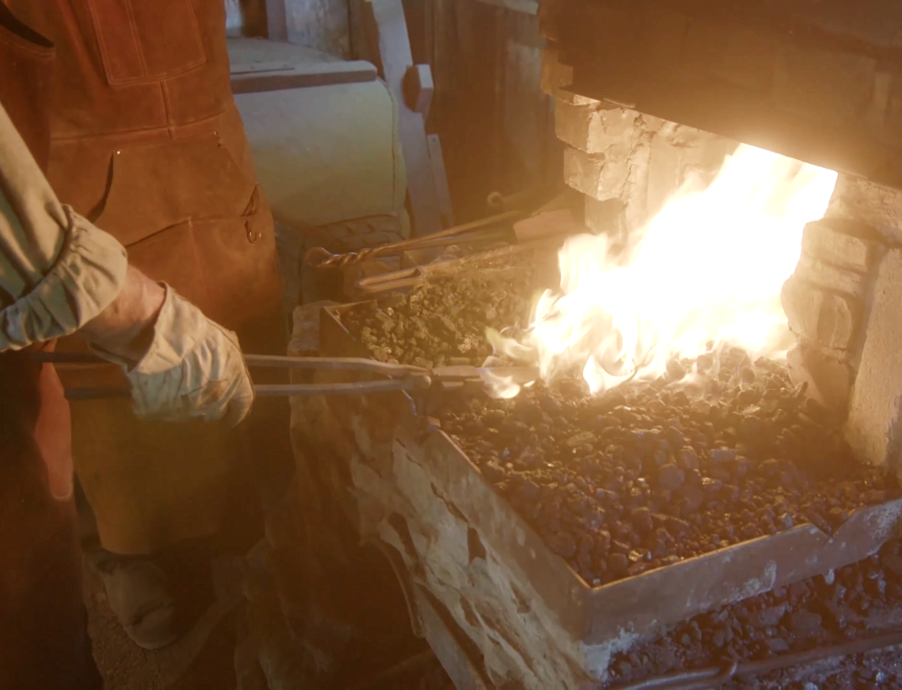

The Science of Blacksmithing

Forging ON: The Evolution of Blacksmithing in Ontario
The Science of Blacksmithing

Subject: Science/Chemistry
Topic: The Science of Blacksmithing
Grade Level: 7 to 12
Time Required: 1 to 2 classes or 1 class and 1 night of homework

Overview
Students will watch the challenge videos on the “Forging ON: The Evolution of Blacksmithing in Ontario” website and identify the various scientific processes a blacksmith relies upon when performing his daily duties.

Objectives/Expectations
Using the trade of blacksmithing as a conduit, students will investigate and understand the practical use of a number of scientific ideas including: particle theory, the properties and applications of pure substances and mixtures, the relationship between heat and matter, and the qualities and properties of various non-metals and metals and the reactions in which they are involved (i.e. combustion, oxidation, etc.).

Curriculum Links
Grades 7 – 8:
- Grade 7, Science and Technology, Understanding Structures and Mechanisms Form and Function, Understanding Basic Concepts, Section 3.6. Identify and describe factors that can cause a structure to fail
- Grade 7, Science and Technology, Understanding Basic Concepts, Section 3.6. Identify the factors that determine the suitability of materials for use in manufacturing a product
- Grade 7, Science and Technology, Developing Investigation and Communication Skills. Use scientific inquiry/experimentation skills to investigate the properties of mixtures and solutions
- Grade 7, Science and Technology, Understanding Matter and Energy Pure Substances and Mixtures, Understanding Basic Concepts, Section 3.1. Distinguish between pure substances and mixtures and use the particle theory to describe the difference between pure substances and mixtures
- Grade 7, Science and Technology, Understanding Matter and Energy Pure Substances and Mixtures, Understanding Basic Concepts, Section 3.7. Describe the processes used to separate mixtures or solutions into their components, and identify some industrial applications of these processes
- Grade 7, Science and Technology, Understanding Earth and Space Systems Heat in the Environment, Understanding Basic Concepts, Developing Investigation and Communication Skills, Section 2.2. Investigate the effects of heating and cooling on the volume of a solid, a liquid, and a gas
- Grade 7, Science and Technology, Understanding Earth and Space Systems Heat in the Environment, Understanding Basic Concepts, Section 3.1. Use the particle theory to compare how heat affects the motion of particles in a solid, a liquid, and a gas
- Grade 7, Science and Technology, Understanding Earth and Space Systems Heat in the Environment, Understanding Basic Concepts, Section 3.2. Identify ways in which heat is produced

Grades 9 – 12:
- Grade 10 Academic, Science, Strand C. Chemistry: Chemical Reactions, Understanding Basic Concepts, Section C3.5. Describe, on the basis of observation, the reactants in and products of a variety of chemical reactions
- Grade 9 Academic, Science, Strand C. Chemistry: Atoms, Elements, and Compounds, Understanding Basic Concepts, Section C3.4. Describe the characteristic physical and chemical properties of common elements and compounds
- Grade 10 Academic, Science, Strand C. Chemistry: Chemical Reactions, Developing Skills of Investigation and Communication, Section C2.3. Use an inquiry process to investigate the chemical reactions of elements (e.g., metals, non-metals) with other substances (e.g., oxygen, acids, water)
- Grade 11 University Preparation, Science, Strand C. Chemical Reactions, Understanding Basic Concepts, Section C3.1. Identify various types of chemical reactions, including synthesis, decomposition, single displacement, double displacement, and combustion
- Grade 12 University Preparation, Science, Strand C. Structure and Properties of Matter, Developing Skills of Investigation and Communication, Section C2.5. Predict the type of solid formed by a given substance in a chemical reaction, and describe the properties of that solid
- Grade 12 University Preparation, Science, Strand C. Structure and Properties of Matter Developing Skills of Investigation and Communication, C2.6. Conduct an inquiry to observe and analyse the physical properties of various substances and to determine the type of chemical bonding present in each substance
- Grade 12 College Preparation, Science, Strand C. Organic Chemistry, Understanding Basic Concepts, Section C3.4. Use structural formulae to describe some simple organic chemical reactions
- Grade 12 College Preparation, Science, Strand D. Electrochemistry, Relating Science to Technology, Society, and the Environment, Section D1.2. Analyse, on the basis of research, the causes of metal corrosion, and assess some techniques used to protect metals from corrosion

Materials & Sources
- “Forging ON: The Evolution of Blacksmithing in Ontario” website (www.ForgingON.ca)
- The Science of Blacksmithing Worksheet

Procedure
- This worksheet simulates the scientific process by posing questions to which students will hypothesize responses based on existing knowledge, do guided research on the “Forging ON: The Evolution of Blacksmithing in Ontario” website to test their responses and revise their answers with more information, and draw conclusions about what they’ve seen and experienced.
- Students will hypothesize answers to questions in Part 1 of the worksheet.
- Students will view the challenge and solution videos located on the “Forging ON: The Evolution of Blacksmithing in Ontario” website before completing Part 2 of the worksheet. The video content is designed to reflect curriculum connections taught in class; together this information will be used to hypothesize answers to questions in Part 2 of the worksheet.
- Students will identify scientific concepts they noticed in the videos. Outside research should not be necessary in Part 3.

Adaptations
In order to save time and resources, and for students who desire collaborative work, this lesson plan can be undertaken by groups of 3 to 4 students.

The worksheet and videos associated with this lesson plan could also serve as resources for a larger, more general project regarding the “Science of” various occupations. In groups, students can choose which occupation, both contemporary and historical, they wish to investigate under a scientific lens. The resources associated with this lesson plan can help with research and serve as a template for what the finished product can look like (video, game, worksheet, etc. outlining the scientific concepts involved with their chosen occupation).

Notes
This lesson plan introduces students to the role of scientific processes in real world occupations and how understanding the science behind one’s work can increase quality and efficiency. This is especially important for students who wish to pursue a career in the trades, as it teaches them how the scientific concepts that they have learned about in school have a practical application. Additionally, it is fun and interactive, but also safe and mess-free.

The Science of Blacksmithing Worksheet

Part 1: Introduction to Blacksmithing

- What do you think of when you see the term blacksmithing? Does it strike you as a science-heavy occupation?

- Without doing any research, how would you explain the general process of blacksmithing?

- What scientific processes do you think are involved in blacksmithing?

Part 2: The Science of Blacksmithing

Watch the challenge and solution videos on the “Forging ON: The Evolution of Blacksmithing in Ontario” website (www.ForgingON.ca) and then answer the following questions to the best of your abilities without using outside sources (your responses are theories, or hypotheses, that you will test):

- Identify three scientific concepts that appear in the videos. Explain the role of these concepts in the process of blacksmithing.

- Compare the physical properties of wrought iron, cast iron, and steel. Why is an alloy such as carbon steel harder and stronger than pure iron?

- What does the blacksmith use as fuel for his forge? How does the blacksmith create it? Why is that fuel more effective than the original material?

- How does pumping the bellows allow a blacksmith to increase the temperature of their forge?

- How can a blacksmith tell what temperature their metal is without a thermometer? What causes a metal to turn a different colour when it increases or decreases in temperature?

- Why does the blacksmith need to heat the metal before they are able to hammer it into shape?

- Why does a blacksmith use annealing and how does it work?

- How does the smelting of raw iron ore in a high temperature furnace produce nearly pure iron?

- How does the rusting of iron occur? What methods can a blacksmith rely on to inhibit rusting?

- Why is quenching used and how does it work? How does quenching a metal in water differ from quenching it in oil?

