Forging ON:
The Evolution of Blacksmithing in Ontario

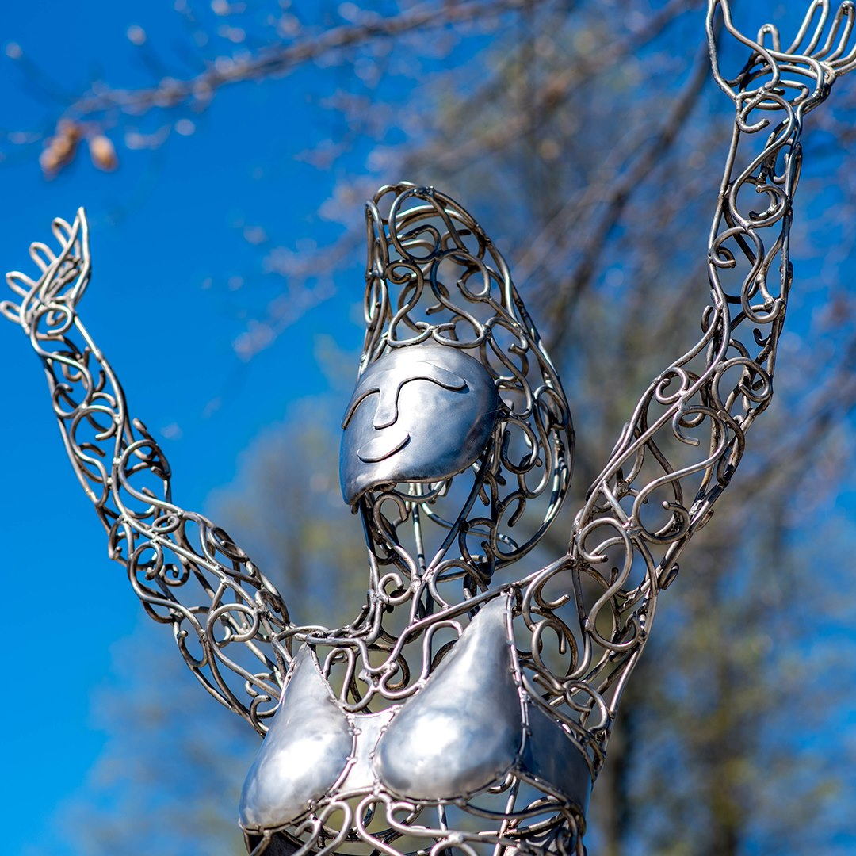

The Art of Blacksmithing

Forging ON: Evolution of Blacksmithing in Ontario
The Art of Blacksmithing

Subject: Art
Topic: The Art of Blacksmithing
Grade Level: 7 to 12
Time Required: 3 to 4 classes

Overview
Students will examine various examples of Canadian blacksmithing art throughout the past few decades and watch videos illustrating the method of their production. Using craft wire, clay, plasticine and metallic finishes, students will then mimic the process and style of blacksmith artists.

Objectives/Expectations
The primary purpose of this exercise is to expose students to a niche, yet traditional art form which is significant to Canada’s history and culture. Recognizing artistic practices in their historical and cultural contexts can motivate students to think more deeply about their own art-making process and inspire their own creations. This exercise also emphasizes reliance on the creative process and the exploration of the elements and principles of design in creative and unorthodox ways.

Curriculum Links

Grades 7 – 8:
- Grades 7 and 8, Strand D. Visual Arts, Principles of Design. Develop an understanding of all principles of design (that is, contrast, repetition and rhythm, variety, emphasis, proportion, balance, unity and harmony, and movement)
- Grades 7 and 8, Strand D. Visual Arts, Elements of Design. Develop an understanding of all elements of design (that is, line, shape/form, space, colour, texture, and value)
- Grades 7 and 8, Strand D. Visual Arts, Creating and Presenting, Section D1. Apply the creative process to produce art works in a variety of traditional two- and three dimensional forms, as well as multimedia art works
- Grades 7 and 8, Strand D. Visual Arts, Creating and Presenting, D1.4. Use a variety of materials, tools, techniques, and technologies to determine solutions to increasingly complex design challenges
- Grade 7, Strand D. Visual Arts, Reflecting, Responding, and Analysing, Section D2.2. Explain how the elements and principles of design are used in their own and others’ artwork to communicate meaning or understanding
- Grade 7, Strand D. Visual Arts, Reflecting, Responding, and Analysing, Section D2.3. Demonstrate an understanding of how to read and interpret signs, symbols, and style in art works
- Grades 7 and 8, Strand D. Visual Arts, Exploring Forms and Cultural Contexts. Section D3. Demonstrate an understanding of a variety of art forms, styles, and techniques from the past and present, and their sociocultural and historical contexts
- Grade 8, Strand D. Visual Arts, Exploring Forms and Cultural Contexts, Section D3.1. Identify and explain some of the ways in which artistic traditions in a variety of times and places have been maintained, adapted, or appropriated

Grades 9 – 12:
- Grades 11 and 12, Strand A. Creating and Presenting, Exploring and Creating in the Arts, Elements and Principles of Design, Section A2. Apply elements and principles of design to create art works for the purpose of self-expression and to communicate ideas, information, and/or messages
- Grade 11, Strand A. Visual Arts, Creating and Presenting, Production and Presentation, Section A3.1. Explore and experiment with a variety of media/materials and traditional and/or emerging technologies, tools, and techniques, and apply them to produce art works

Materials & Sources
- “Forging ON: The Evolution of Blacksmithing in Ontario” Website (www.ForgingON.ca)
- Artist William “Bill” Lishman’s Website (http://williamlishmanartist.com/)
- The Art of Blacksmithing Worksheet
- Sketching paper and pencils
- Craft wire
- Plasticine
- Grey Clay
- Various sculpting tools
- Metallic paints or pigments
- Paint brushes
- Buff cloth
- Wax
- Optional: Scrap metal (nuts, bolts, screws, etc), Hot glue gun/super glue/soldering kit
Procedure
- Students explore the “Forging ON: The Evolution of Blacksmithing in Ontario” website timeline and challenge videos, paying particular attention to the method of blacksmithing and the evolution of blacksmithing from a practical trade to a niche form of art making.
- With an emphasis on the 1880’s, 1960’s, and 2022 sections, students fill in Part 1 of the Art of Blacksmithing Worksheet.
- In Part 2 of the worksheet, students then choose a piece of blacksmithing art from the website’s art gallery (i.e. a Victorian Arts & crafts piece, a Bill/Geordie Lishman piece, or a modern Fleming piece) to analyse in detail.
- With knowledge of the method, techniques, and style of blacksmithed art, students prepare their own blacksmithing-inspired piece of sculptural art using the creative process. They begin by brainstorming ideas and then sketching prospective projects. In the spirit of the metal art of the Lishmans, the students should plan a sculpture of a human or animal in motion, which in turn represents a meaningful location to them in Canada.
- When confident with one of their ideas, students build a metal skeleton out of craft wire and/or plasticine. Students should focus on portraying movement with this armature.
- Students create a sculpture over the craft wire, relying on their sketches and observations. Utilizing a variety of tools such as toothpicks, pencils and sculpting devices, students can add texture to the sculpture and implement details that portray the illusion of movement. Students can also create supportive bases to hold the sculpture’s weight. The clay sculptures are then baked (unless air dried clay or plasticine is being used).
- In order to simulate blacksmithed metal art, students will avoid utilizing various colours for their sculptures and instead will rely on the other elements of design. However, they may paint/coat their sculptures monochromatically using metallic paints/pigments to simulate the appearance of metal. Students may also wish to explore with different washes, buffs, and waxes to find the right metallic finish for their sculpture.
- When complete, students choose a partner to compare creations. They will analyze the technique, style, and meaning of the two sculptures. They will also discuss how the procedure and end product would differ if they were blacksmithing metal rather than using moulding clay for their sculptures.

Adaptations
If the equipment is available and the class size is small, teachers may wish for their students to make their sculptures entirely out of metal using scrap metal (such as nuts, bolts, screws, tin cans, etc.) and soldering kits (hot glue and/or super glue may work as well). This not only captures an increased likeness to actual blacksmithed metal art than achieved with moulding clay, but it also replicates one of the key aspects of modern blacksmithed art: the environmentally responsible method of reusing old material to create artwork.

Notes

This lesson plan is valuable as it shines a light on an overlooked form of art, its historical and cultural context as it connects to Canada, and the associated Canadian artists who practised the niche craft. It will also demonstrate to students that blacksmithing is not an extinct tradecraft, but rather it has evolved with the changing times. This may inspire some students to pursue blacksmithing, either as a hobby or as a career.

It also provides a unique spin to three-dimensional sculptural art activities by encouraging the students create a metal armature, rely considerably on expressing movement and texture, tie the project to a place significant to them, avoid the usage of a variety of colours, and experiment with creating a believable faux-metal finish.

The Art of Blacksmithing Worksheet

Part 1: Introduction to Blacksmithed Metal Art

- What is your first impression of blacksmithed metal art?

- Why and when did blacksmithing transform from a practical trade to a niche art form?

- What are some of the unique benefits of blacksmithing metal art? What can a blacksmith artist achieve with their craft that is difficult to replicate in other art forms?

- Has the procedure of creating blacksmith metal art changed much within the past 150 years? Describe how it has evolved or remained the same.

- What is one of the first examples of blacksmithed metal art on the “Forging ON” website? Why was it made and what was its historical context? Is its style unique to the time period it was made?

- What elements and principles of designs does blacksmithed metal art tend to utilize the most?

- How has Canada’s land, people, history, and culture influenced blacksmithed metal art?

Part 2: Case Study

Visit blacksmith artist Bill Lishman’s website (http://williamlishmanartist.com/). Click on the “Sculpture” tab. Choose a piece of blacksmithed art to analyze in depth using the follow questions:

- Description: What do you see? What words would you use to describe it? How would you describe the lines, the shapes, the colours, the use of light and shadow, and the overall style?

- Connection: What does this art remind you of? What things do you recognize and what appears to be new? Why were you drawn to this piece initially?

- Analysis: Assess this piece through the lens of the elements and principles of design.
  - Elements: colour, form, line, shape, space, texture, value; and
  - Principles: balance, emphasis, harmony, movement, proportion, rhythm, unity, variety

- Interpretation: What does the title reveal about this piece or what title would you give it without knowing? Who made this piece and when? Does the historical context matter to understand this piece? What is its purpose? How do you think the artist created this piece? What materials and tools do you think the artist used? How might this piece be created differently in more modern or historic times?

- Evaluation: In what ways is this piece successful? What things would you change? Why is it memorable? Is this piece more than just aesthetically pleasing? Does it have depth through the representation of an emotion, a cause, a message, an event, a place, etc.? Does it use symbolism? What is the artist trying to communicate through the work?

Part 3: Sculpture-making Activity

With knowledge of the method, techniques, and style of blacksmithed art, prepare your own blacksmithing-inspired piece of sculptural art using the creative process. Brainstorm ideas and sketch prospective projects. In the spirit of the metal art of blacksmith artist Bill or Geordie Lishman, plan a sculpture of a human or animal in motion, which in turn represents a meaningful location to you.

When confident with one of your ideas, build a metal skeleton out of craft wire. Focus on portraying movement with this armature.

Then create a sculpture out of grey clay or plasticine over the armature, relying on your sketches and observations. Utilize a variety of tools such as toothpicks, pencils and sculpting devices to add texture to the sculpture. Bake the clay or allow it to air dry.

In order to simulate blacksmithed metal art, you may not use varying colours for your sculptures. However, you may paint/coat your sculptures monochromatically using metallic paints/pigments to simulate the appearance of metal. You may also wish to explore different washes, buffs, and waxes to find the right metallic finish.

Part 4: Self-Reflection

After going through the creative process and completing your blacksmithing-art inspired sculpture, answer the following questions:

- What is the title of your sculpture?

- How did you use the creative process? What planning and problem-solving steps did you perform? How did this impact the actual sculpture-making procedure and final product?

- How did your design change or improve based on feedback from peers and teachers? What revisions or refinements did you make?

- What elements and principles of design were used in the creation of your sculpture? Which are the most prominent? How would your sculpture change if you were to emphasize different elements and principles?

- How did you create your sculpture, what tools, techniques and processes did you use to create your structure?

- What inspired the design of your sculpture? Where did your ideas come from?

- What did you learn while creating the sculpture?

- Is this the final sculpture that you imagined? What would you change or improve?

- Find a partner and compare the techniques, styles, and meanings of your two sculptures.

- Discuss the following question with your partner: Due to the constraints of the classroom, you made your sculpture out of clay rather than metal. How would the procedure and end product differ if you were blacksmithing metal rather than using moulding clay or plasticine?

